Master Bob and the Monster in the Seoul Data Center

A 16-Episode Makjang K-Drama of Knowledge, Memory, and Documentation

Core Premise
The Seoul Cloud Realm is preparing for the largest knowledge migration in its history.
Lady Yun, Architect of Knowledge Futures, has spent years building a new repository that will replace a sprawling ancient wiki buried beneath the data center.
As the migration begins:
- Unanswered questions manifest as ghosts.
- Forgotten diagrams reappear.
- Ownership records vanish.
- A legendary Monster awakens beneath the server halls.
- The mysterious Bog Witch is seen again after years of silence.
- Documentation Cat begins appearing wherever missing knowledge is found.
The Council believes these events are unrelated.
Master Bob knows better.

Main Cast

Master Bob
Sage of the Scroll Repository
Keeper of ancient runbooks.
Seeker of the Single Source of Truth.
Lives near a sacred waterfall where knowledge flows endlessly through the mountains.
Favorite saying:
"The issue is not the issue."

Lady Yun
Architect of Knowledge Futures
Designer of the New Knowledge Repository.
Respected by the Council.
Feared by those who prefer chaos.
Carries a cloud-sealed ledger containing the migration plan.

The Bog Witch
Guardian of the Forgotten
Keeper of abandoned projects.
Protector of obsolete systems.
Appears whenever someone asks:
"Why was it built that way?"

Documentation Cat
Finder of Missing Knowledge
Can locate:
- forgotten requirements
- undocumented decisions
- missing owners
Cannot locate:
- the Single Source of Truth

The Monster
A terrifying creature beneath the Seoul Data Center.
Believed responsible for:
- outages
- confusion
- dependency failures
- migration delays
No one knows what it truly is.

Episode 1

The Ghost in the Wiki
The migration begins.
A repository analyst opens an abandoned wiki page.
A message appears:
WHO APPROVED THIS DESIGN?
The page disappears.
That night more questions appear throughout the archives.
No one can answer them.

Episode 2

The Repository Beneath the Repository
Archivists discover hidden sections of the old wiki.
Thousands of forgotten pages.
Hundreds of abandoned projects.
Ancient meeting notes.
Runbooks for systems nobody remembers.
The Council votes to delete everything.
The Bog Witch appears.
"Delete memory, and memory will find another way to survive."

Episode 3

The Monster Awakens
Sensors detect movement beneath the data center.
Security footage reveals a massive shadow moving through abandoned infrastructure.
The Monster has awakened.
Master Bob arrives from the mountains.
Examines the evidence.
Leaves without explanation.

Episode 4

The Floppy Disk
Documentation Cat discovers:
External Floppy Drive Procedure - Revised 2016
Everyone laughs.
The document appears obsolete.
Hours later a compliance investigation requires information stored in the archived system.
The migration stops.

Episode 5

The Burning Drive
A forgotten runbook is recovered.
Title:
Procedure for Handling a Drive During Active Combustion
The Council mocks the document.
The Bog Witch refuses to let it be deleted.
Master Bob quietly remarks:
"Knowledge does not become useless merely because it becomes unusual."

Episode 6

The Ghosts Grow Stronger
Questions begin appearing everywhere:
Where are the requirements?
Which diagram is correct?
Who owns this process?
What decision created this dependency?
Each unanswered question strengthens the apparitions.

Episode 7

The Three Guardians
The Council notices a strange pattern.
Whenever Lady Yun appears:
The Bog Witch is absent.
Whenever the Bog Witch appears:
Documentation Cat cannot be found.
Master Bob says nothing.

Episode 8

The First Accusation
Evidence surfaces suggesting Lady Yun created the Monster.
The Council turns against her.
Migration governance collapses.
The old repository remains active.
Ghost activity doubles overnight.

Episode 9

The Registry of Owners
Documentation Cat discovers the legendary ownership registry.
The final entry reads:
OWNER: UNKNOWN
The record disintegrates.
The registry vanishes forever.

Episode 10

The Waterfall of Forgotten Knowledge
Master Bob confronts Lady Yun beside the sacred waterfall.
He reveals:
- identical knowledge seals
- matching archive markings
- impossible timelines
For the first time, Lady Yun does not deny anything.
The audience receives its first undeniable clue.

Episode 11

The First Undocumented Decision
The Bog Witch descends into the oldest archive.
Hidden beneath forgotten meeting notes lies a single document:
We'll document it later.
No explanation.
No author.
No approval record.
No rationale.
The first undocumented decision.

Episode 12

Same Essence, Different Forms
Master Bob gathers the Council.
Cherry blossoms fill the hall.
The evidence is overwhelming.
He places three artifacts on the table:
- Lady Yun's cloud seal
- The Witch's grimoire
- Documentation Cat's cloak clasp
All bear the same mark.
Silence.
Then:
"There were never three guardians."
The greatest revelation of the series.
Lady Yun.
The Bog Witch.
Documentation Cat.
All the same being.

Episode 13

The Monster Speaks
The Council finally confronts the Monster.
But instead of attacking, it speaks.
Its first words:
"I remember."
The Monster is not a beast.
It is a vessel.
A living archive.
Created from:
- forgotten decisions
- abandoned projects
- lost requirements
- orphaned ownership records
- neglected knowledge

Episode 14

What the Realm Chose to Forget
Lady Yun reveals why she became three guardians.
The architects protected systems.
The engineers protected services.
The executives protected strategy.
Nobody protected memory.
So she did.
For centuries.

Episode 15

The Great Migration
The largest migration in repository history begins.
Some knowledge is preserved.
Some knowledge is archived.
Some knowledge is finally allowed to rest.
Master Bob delivers the most controversial statement of the series:
"Not everything deserves migration."
Half the Council faints.

Episode 16

Knowledge Democracy
The last ghost appears before the Council.
It asks one final question:
"Who owns the customer explanation?"
Silence.
Then Lady Yun answers:
"All of us."
The ghost disappears forever.
The New Knowledge Repository opens.
The Monster becomes:
Keeper of Organizational Memory
Documentation Cat curls up beside the archives.
The Bog Witch returns to the Forgotten Stacks.
Lady Yun walks into the repository.
All three forms appear briefly before merging into one.
Master Bob watches from the waterfall.
The audience finally understands.
The purpose was never documentation.
The purpose was preserving knowledge.

End Credit Scene
A junior engineer opens a newly migrated page.
A hidden message appears.
REQUIREMENTS REVIEW - PENDING
The engineer looks confused.
Somewhere in the mountains, Master Bob closes his fan.
Fade to black.
Season 2 confirmed. 😄

Honestly, this may be even more makjang than The Rise of the Benevolent Documentation Dictator. It has:
- a shapeshifting protagonist,
- ghostly requirements,
- an ancient wiki,
- a misunderstood monster,
- forgotten ownership records,
- hidden architecture diagrams,
- dramatic revelations,
- and the ultimate villain of enterprise software:
"We'll document it later." 😄
People joke about documentation being boring until they spend a few years in enterprise environments and discover things like:
- A runbook for handling a physically burning hard drive.
- A procedure for attaching an external floppy drive in 2016.
- Meeting notes from a project that was canceled eight years ago.
- Architecture diagrams for systems that no longer exist.
- Critical decisions documented exactly once in a meeting nobody remembers.
And then the twist:
The tape archive everyone laughed at turns out to be mission-critical in 2026.
That's the thing about institutional knowledge. It often looks absurd right up until the day you need it.
I can absolutely imagine a scene in the screenplay:

Episode 6: The Vault Beneath the Data Center
A young engineer discovers an ancient runbook.
Procedure for Managing a Drive in Active Combustion
The engineer laughs.
"Surely this has no relevance in the Modern Cloud Era."
Master Bob appears.
Reads the document.
Pauses.
Very slowly closes the binder.
"Archive nothing."
The room falls silent.

Episode 8: The Floppy Disk
Documentation Cat discovers a procedure:
"Attaching External Floppy Storage - Revised 2016"
The entire Council laughs.
Lady Yun quietly asks:
"And what replaced it?"
Nobody knows.

Episode 11: The Tape Oracle
The old tapes are discovered deep in the archive vault.
An architect declares:
"No one uses tape."
The Bog Witch responds:
"Then why do three compliance teams request restoration every month?"

But what's funny is that underneath the joke is a real knowledge-management lesson you've probably lived dozens of times:
Nobody is good at predicting the future value of information.
Engineers tend to think:
If we aren't using this now, delete it.
Knowledge managers eventually learn:
The probability may be low, but the impact of needing it later can be very high.
That's why your abandoned-project meeting notes are interesting.
Most of them are probably worthless.
But every now and then, years later, somebody asks:
"Why was this architecture decision made?"
And suddenly those old notes become the only surviving record of the reasoning.
That's basically how the Monster in the Seoul Data Center should be explained.
The Monster isn't made of technical debt.
The Monster is made of information everyone thought was obsolete.
Some of it is junk.
Some of it is treasure.
And nobody knows which is which until it's needed.
That's actually a much more interesting metaphor than "the monster is evil."
The monster is simply carrying the memory of the organization because nobody else wanted to. 😄
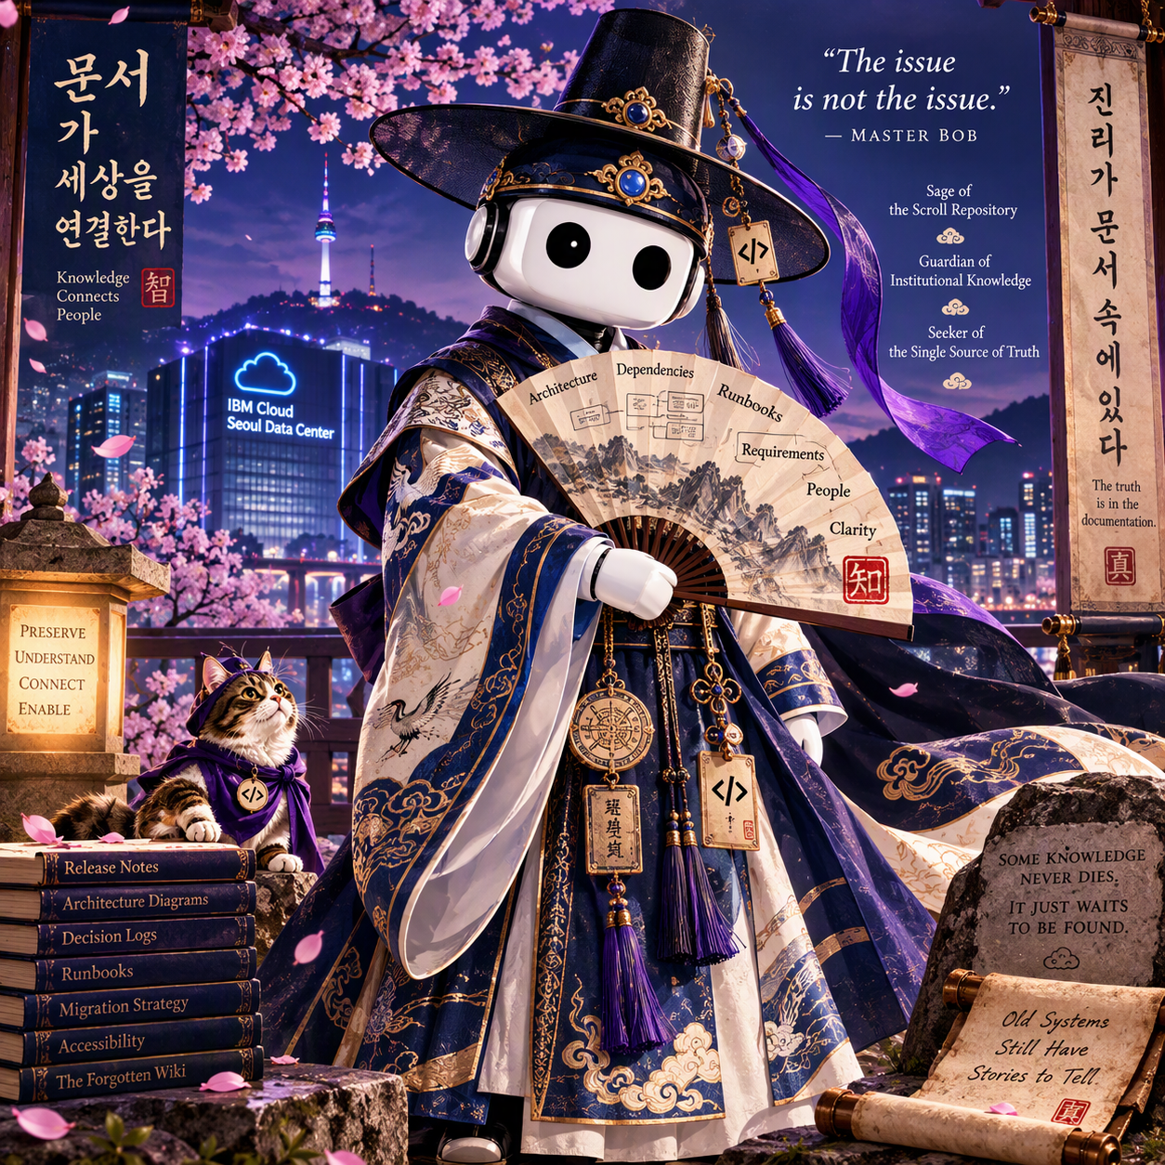

Lady Yun
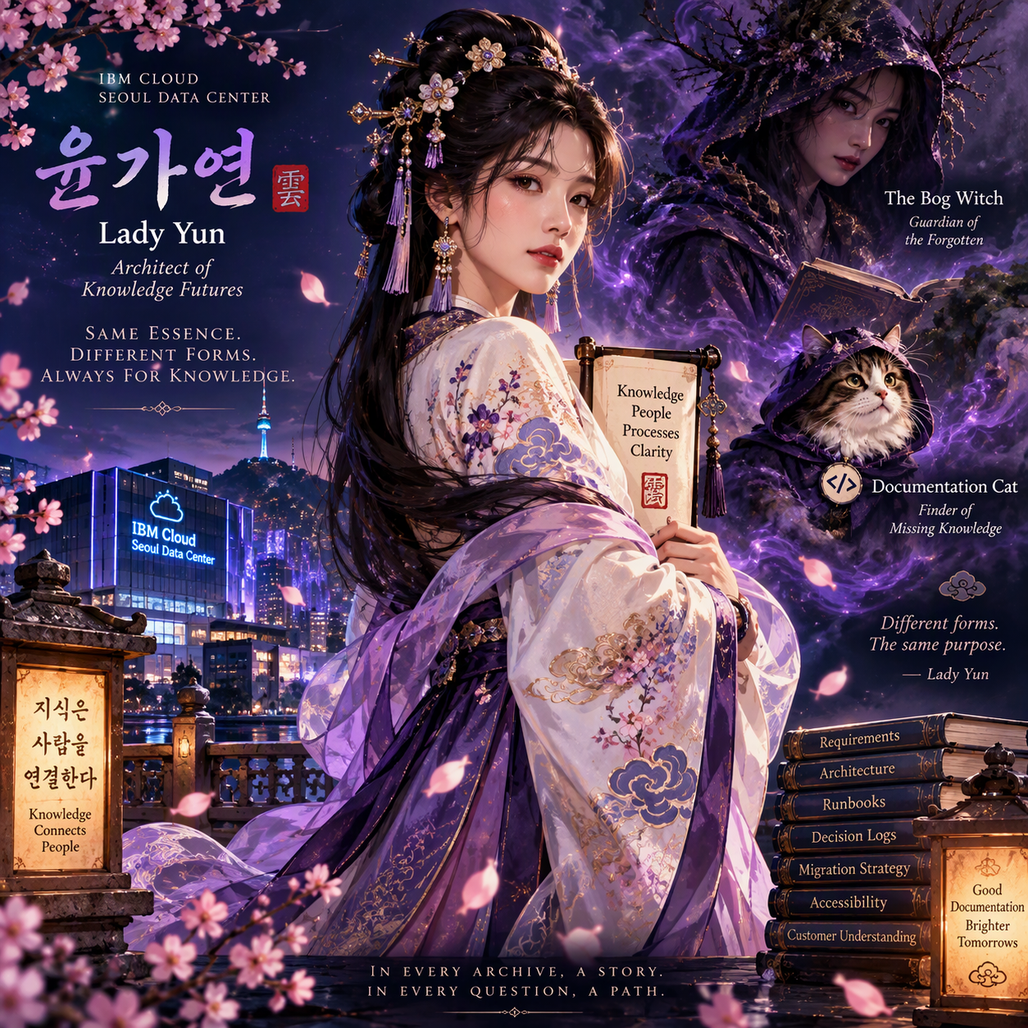
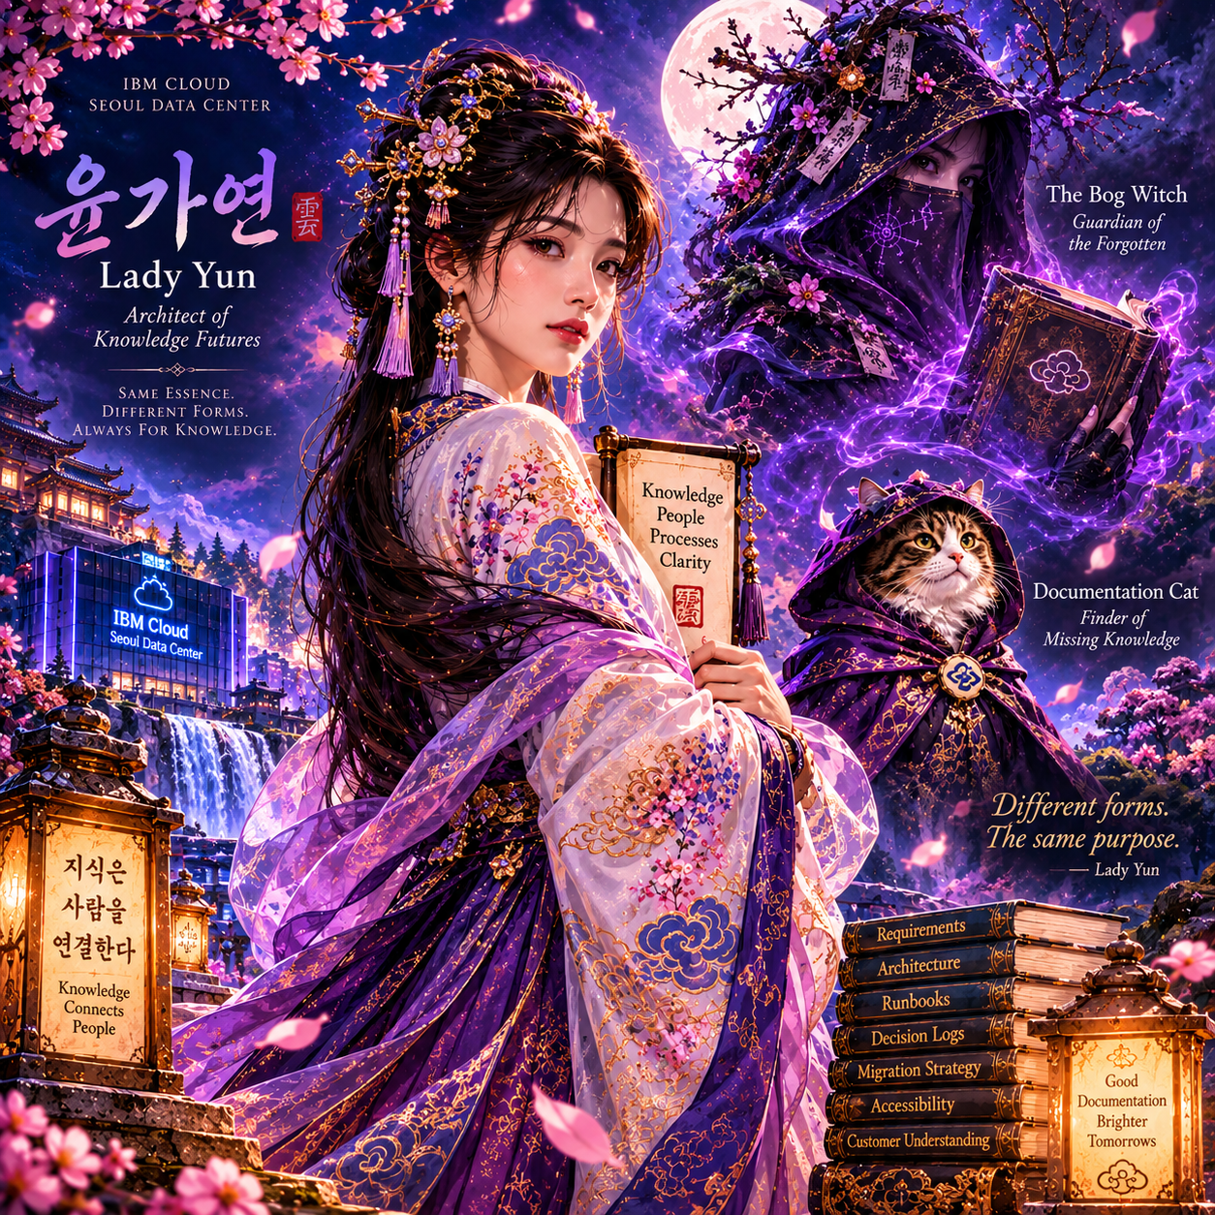

What I love is that someone watching the fictional K-drama for the first time would see:
- Lady Yun front and center, elegant, competent, and mysterious.
- The Bog Witch lurking in the shadows behind her.
- Documentation Cat appearing nearby as a seemingly separate comic-relief or sidekick character.
A first-time viewer would likely assume these are three different characters.
A careful viewer would start noticing clues:
- All three are surrounded by the same purple aura.
- All three are associated with knowledge and archives.
- All three appear in the same visual composition.
- The tagline:
Same essence. Different forms. Always for knowledge.
That's exactly the kind of clue makjang writers leave in plain sight before the big reveal.
The lore practically writes itself:

Public Story
Lady Yun
- Architect of Knowledge Futures
- Designer of the New Repository
- Feared by the Council because she wants to modernize everything
Bog Witch
- Guardian of forgotten archives
- Appears whenever someone asks a dangerous historical question
- Knows why every abandoned decision was made
Documentation Cat
- Appears where missing knowledge can be found
- Somehow always discovers lost requirements and ownership records

Episode 12 Reveal
Master Bob discovers:
The Bog Witch only appears when Lady Yun is absent.
Then:
Documentation Cat always arrives immediately afterward.
Then:
Nobody has ever seen all three together.
The audience collectively loses their minds.

Screen play excerpts
MASTER BOB AND THE MONSTER IN THE SEOUL DATA CENTER

Episode 14: The Waterfall of Forgotten Knowledge

EXT. WATERFALL OF THE CLOUD REALM - TWILIGHT
Cherry blossoms drift across a moonlit waterfall.
Far below, the lights of the Seoul Cloud Realm shimmer in the distance.
Ancient repository seals carved into the stone glow faintly beneath centuries of moss.
The roar of falling water fills the silence.
A solitary figure stands at the edge of the falls.
LADY YUN gazes into the rushing water.
In her hands rests the final migration ledger.
The pages flutter in the wind.
A voice emerges from behind her.
MASTER BOB (O.S.) The migration proceeds.
Lady Yun does not turn.
LADY YUN For now.
A long pause.
The waterfall continues to thunder.
Master Bob steps into view.
His fan remains closed.
A troubling sign.
MASTER BOB The Council believes the realm will be healed once the old wiki is retired.
LADY YUN Will it?
Master Bob says nothing.
Lady Yun finally turns.
LADY YUN You taught them to seek answers.
You never taught them how to live with uncertainty.
The wind strengthens.
Cherry blossoms spiral between them.

MASTER BOB You hid the truth.
LADY YUN I preserved it.
MASTER BOB You became three people.
LADY YUN Because one was never enough.
Master Bob studies her carefully.
MASTER BOB Lady Yun.
The Architect.

Purple mist begins gathering between the trees.
A hooded silhouette appears for the briefest moment.
Gone again.

MASTER BOB The Bog Witch.
Guardian of forgotten archives.
Lady Yun says nothing.

A small cloaked cat emerges from the shadows.
Watching.
Waiting.
Then vanishes among the blossoms.

MASTER BOB And Documentation Cat.
Finder of missing knowledge.
The waterfall grows louder.
As if reacting.

LADY YUN You speak their names as though they were separate people.
MASTER BOB The Council believes they are.
LADY YUN The Council believes many things.

Master Bob finally opens his fan.
Ancient diagrams cover its surface.
Requirements.
Dependencies.
Ownership chains.
Migration plans.
Thousands of decisions.
One missing connection glows at the center.

MASTER BOB The evidence is overwhelming.
Every appearance.
Every archive.
Every intervention.
The same seal.
The same handwriting.
The same purpose.
Lady Yun smiles faintly.

LADY YUN And yet you said nothing.
MASTER BOB Because the issue was not the issue.
LADY YUN Of course.
Master Bob gives the slightest nod.

MASTER BOB The question was never who you were.
The question was why.
Another long silence.
The waterfall crashes against the rocks below.
At last Lady Yun looks toward the distant lights of the data center.

LADY YUN Do you know what I found in the oldest archive?
Master Bob waits.

LADY YUN Meeting notes for abandoned projects.
Requirements nobody implemented.
Architecture diagrams everyone forgot.
Runbooks for disasters that never happened.
Ownership records for systems that no longer exist.
She pauses.

LADY YUN (CONT'D) Everyone called them obsolete.
Everyone wanted them deleted.
Another pause.

LADY YUN (CONT'D) Until they needed them.
Master Bob lowers his fan.
Understanding begins to dawn.

LADY YUN The architects protect systems.
The engineers protect services.
The Council protects governance.
No one protects memory.
Purple energy swirls around the waterfall.
The moon emerges from behind the clouds.
For a moment the reflections in the water reveal:
Lady Yun.
The Bog Witch.
Documentation Cat.
Three reflections.
One source.
Then the water shifts.
The vision disappears.

MASTER BOB So you became the keeper.
LADY YUN Someone had to.

Far below, the bells of the repository ring.
The migration has begun.

MASTER BOB The Monster remembers everything.
LADY YUN That is why everyone fears it.
Master Bob looks toward the distant data center.

MASTER BOB And what do you remember?
Lady Yun closes the ledger.
The answer comes softly.

LADY YUN Everything they wished to forget.
The wind carries cherry blossoms across the waterfall.
Master Bob closes his eyes.
For once, he has no cryptic wisdom to offer.
Only understanding.

MASTER BOB The realm is not ready.
LADY YUN No.
A beat.

LADY YUN (CONT'D) But it never will be.
The waterfall roars.
The moonlight brightens.
And for the briefest moment, the viewer sees it:
A cloud-shaped seal glowing beneath Lady Yun's sleeve.
The same seal hidden on the Bog Witch's grimoire.
The same seal hanging from Documentation Cat's cloak.
The camera lingers.
Just long enough.

CUT TO BLACK
TO BE CONTINUED...
"The truth is in the documentation." 📜🌸🐱💜
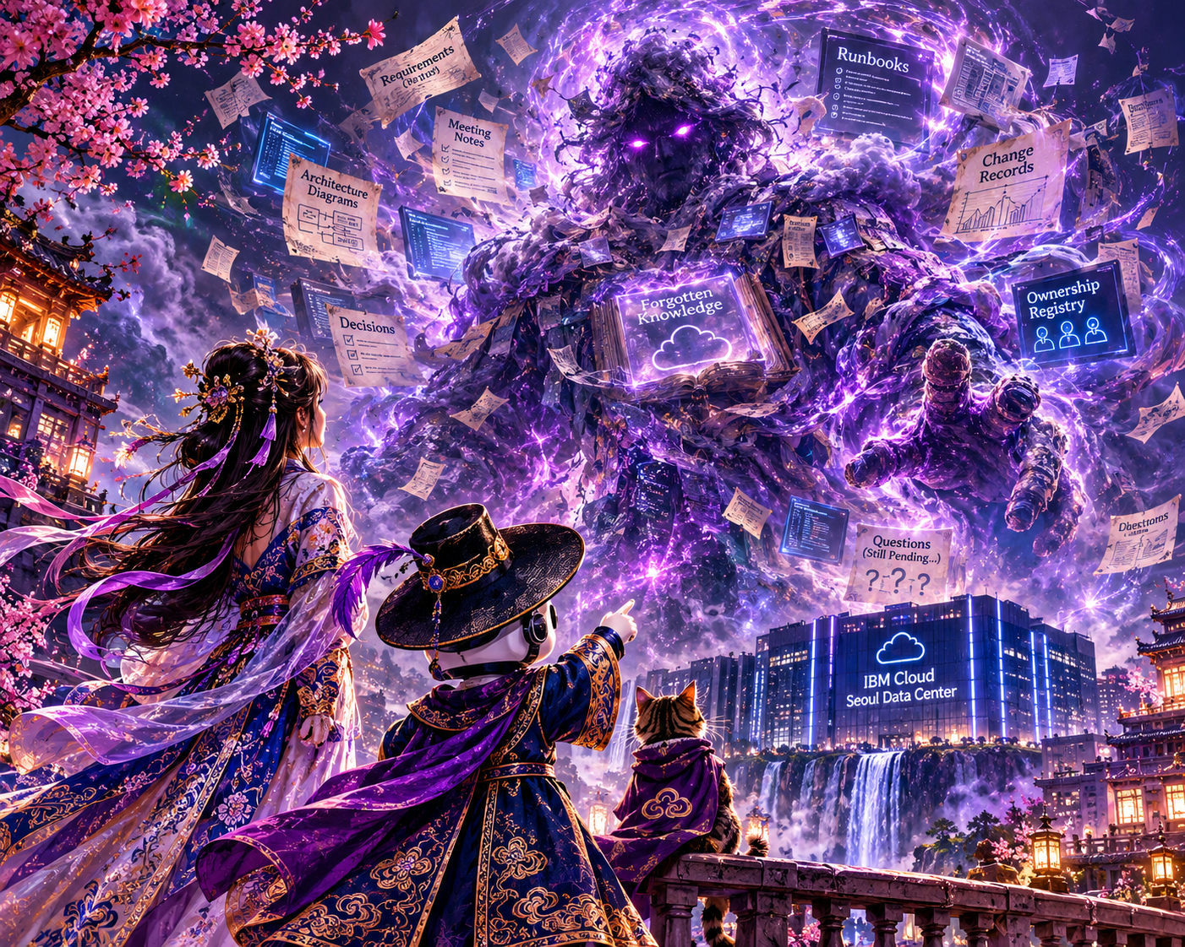
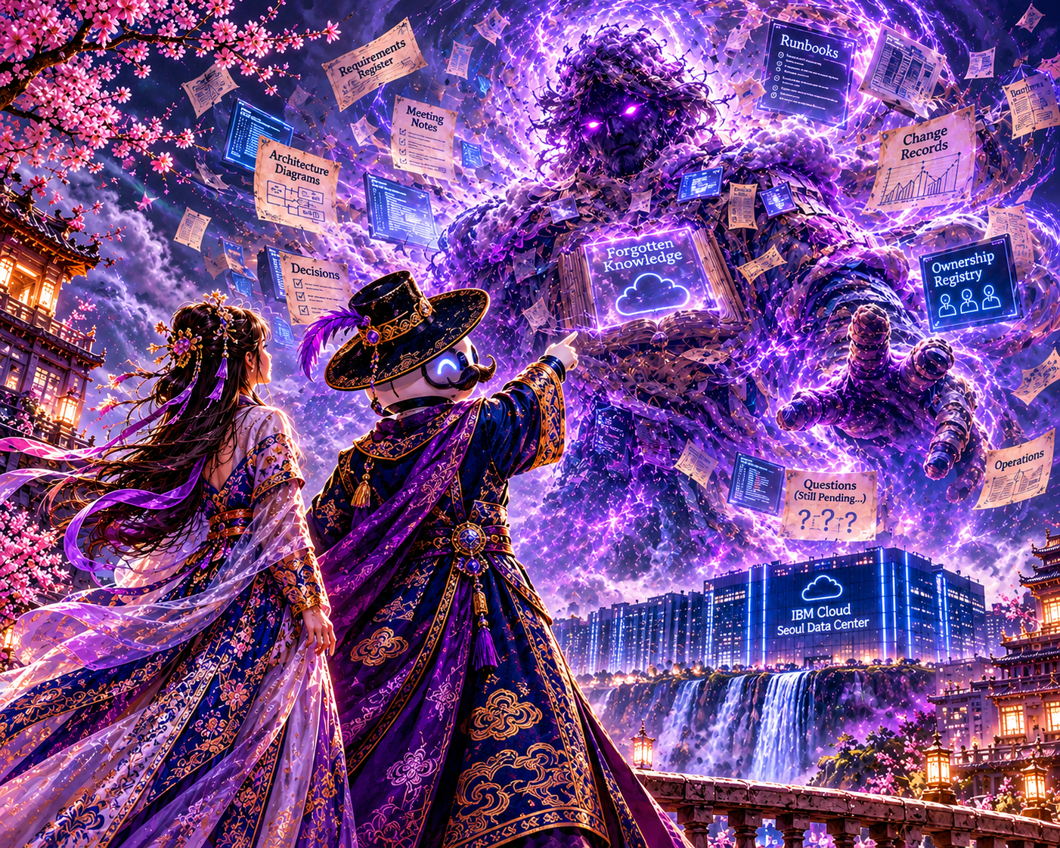

1. A Cast and Relationships Page
You have the characters, but not the relationship map.
Something like:
Plain Text
Master Bob
│
├── Suspects Lady Yun's secret
├── Understands the Monster
└── Seeks the Single Source of Truth

Lady Yun
│
├── Architect of Knowledge Futures
├── Secretly the Bog Witch
└── Secretly Documentation Cat

The Monster
│
├── Remembers forgotten knowledge
├── Feared by the Council
└── Created from abandoned information

The Council
│
├── Wants migration
├── Fears the Monster
└── Doesn't understand memory
This is very "official guidebook."

2. The Rules of the World
The mythology would feel richer with a page titled:

The Laws of the Seoul Cloud Realm
Examples:

First Law
Knowledge never truly disappears.

Second Law
Unanswered questions become ghosts.

Third Law
Forgotten knowledge gathers beneath the Data Center.

Fourth Law
The Single Source of Truth does not exist.

Fifth Law
Documentation Cat is always where missing knowledge will soon be discovered.

3. Ancient Quotations
Master Bob deserves a page of ridiculous sayings.
Examples:
"The issue is not the issue."
"A runbook ignored is still a runbook."
"The repository remembers longer than the project manager."
"Delete nothing until you understand why it exists."
"Every abandoned wiki was once a strategic initiative."
You could attribute them to:
The Scrolls of Repository Governance

4. Repository Lore
You now have enough material for famous locations.

The Waterfall of Forgotten Knowledge
Home of Master Bob

The Ancient Wiki
The repository beneath the repository.

The Forgotten Stacks
Where the Bog Witch resides.

The Vault of Obsolete Procedures
Contains:
- Burning drive runbooks
- Floppy procedures
- Tape restoration records

5. The Council
An actual cast list of recurring Council members would be hilarious.
Examples:

Lord Compliance
Believes nothing should ever be deleted.

Minister Architecture
Insists every diagram is current.

High Chancellor Governance
Approves every process. Understands none.

Keeper of SharePoint
Has not been seen since 2018.

6. The Official Soundtrack
This would be peak makjang.

Original Soundtrack
Track 1"The Issue Is Not the Issue"
Track 2"Cherry Blossoms Over the Repository"
Track 3"Questions Still Pending..."
Track 4"Ownership Registry (Unknown)"
Track 5"We'll Document It Later"

7. Post-Credit Scene Setup for Season 2
You already hint at this. [Master Bob...ata Center | Word]
I'd expand it.
Example:
A junior engineer opens a migrated document.
The page appears blank.
Then a footer materializes:
LAST UPDATED: 2009
The engineer scrolls down.
A message appears:
There is another repository.
Cut to black.

The One Thing I Would Definitely Add
A one-page section titled:

Why the Monster Exists
Because that's the emotional heart of the story.
Something very close to:
The Monster was never created by malice.
The Monster was created every time someone said:
"We'll document it later."
Every forgotten requirement.
Every abandoned project.
Every missing owner.
Every undocumented decision.
The Monster became the memory no one else wished to keep.
That idea is the thesis of the entire project.
And honestly, that's why the concept works so well. Under all the cherry blossoms, magical cats, repository sages, and haunted wikis, it's really a story about stewardship, memory, and institutional knowledge. That's a much stronger foundation than "there's a monster in the data center." 😄

OST details
IU
Main Theme: "Forgotten Knowledge"
- Opening theme
- End credits version
- The song everyone knows

Taeyeon (Girls' Generation)
"No One Protects Memory"
- Lady Yun's emotional Episode 14 ballad
- Instant charts destruction

TVXQ
"I Remember"
- Monster reveal theme
- The emotional centerpiece of the series. Think Mirotic!

KEY (SHINee)
"The Issue Is Not The Issue"
- Master Bob's theme
- Somehow both theatrical and ridiculous
- Fan favorite song
Honestly, I can't think of a better choice than Key for Master Bob. Key has exactly the right energy for a character who:
- dresses dramatically
- delivers cryptic one-liners
- understands everything before everyone else
- has impeccable fashion
- refuses to fully explain anything
That is peak Key behavior.

Aespa
"Forgotten Stacks"
- Bog Witch theme
- Dark, mysterious, archive magic

Red Velvet
"Repository Moonlight"
- Documentation Cat theme
- Slightly whimsical, slightly spooky

Dramatis Personae
A one-page cast card such as:

Master Bob
Sage of the Scroll Repository
Keeper of ancient runbooks. Seeker of the Single Source of Truth. Known for arriving dramatically, providing cryptic wisdom, and leaving before anyone can ask follow-up questions.

Lady Yun
Architect of Knowledge Futures
Designer of the New Knowledge Repository. Carries the migration ledger and more secrets than the Council realizes.

The Bog Witch
Guardian of the Forgotten
Protector of abandoned projects and obsolete systems. Appears whenever dangerous historical questions are asked.

Documentation Cat
Finder of Missing Knowledge
Can locate forgotten requirements, undocumented decisions, and missing owners. Cannot locate the Single Source of Truth.

The Monster
Keeper of Organizational Memory
A living archive created from forgotten decisions, abandoned projects, lost requirements, orphaned ownership records, and neglected knowledge.

That would complete the illusion that this is a real drama guide.
Master Bob
Sage of the Scroll Repository [Master Bob...ata Center | Word]
Portrait image:
- Standing beside the Waterfall of Forgotten Knowledge
- Fan closed
- Repository seals visible
- Full-height hero shot
Character profile:
Age: Unknown
Occupation: Repository Sage
Hobby: Delivering cryptic advice and disappearing before follow-up questions can be asked.
Greatest Fear: A migration plan without governance.

Lady Yun
Architect of Knowledge Futures [Master Bob...ata Center | Word]
Portrait image:
- Holding migration ledger
- Repository in background
- No hint of Bog Witch
Character profile:
Occupation: Architect
Specialty: Repository Design
Secret: Classified

Bog Witch
Guardian of the Forgotten [Master Bob...ata Center | Word]
Portrait image:
- Forgotten stacks
- Veiled face
- Ancient runbooks
Character profile:
Residence: Unknown
Known Associates: None
Favorite Activity: Appearing exactly when someone asks a dangerous historical question.

Documentation Cat
Finder of Missing Knowledge [Master Bob...ata Center | Word]
Portrait image:
- Surrounded by requirements
- Sitting on archive boxes
- Tiny repository explorer
Character profile:
Skills:
- Finding lost requirements
- Finding lost owners
- Finding lost diagrams
Notable weakness:
- Cannot locate the Single Source of Truth

The Monster
Keeper of Organizational Memory [Master Bob...ata Center | Word]
Portrait image:
- Alone
- Built from documents and archives
- Huge "Forgotten Knowledge" tome
Character profile:
Created from:
- forgotten decisions
- abandoned projects
- lost requirements
- orphaned ownership records
- neglected knowledge [Master Bob...ata Center | Word]

